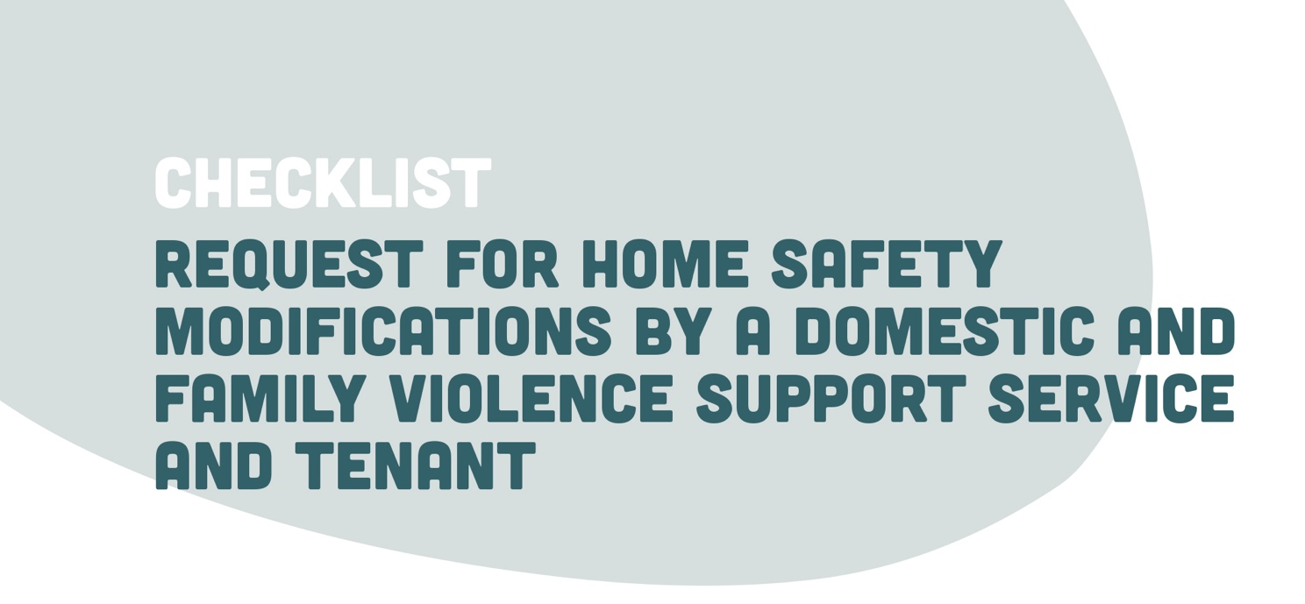

When a request has been made to the CHP to undertake modifications to increase safety in the property, the following questions should be explored with the domestic and family violence support service and tenant:
- Has the support provider / police utilised a domestic violence safety assessment tool to assess areas of risk? |  |  | YES □ | NO □
- What process has been used to guide the decision making about the safety modifications that are required to enable the tenant to remain as safely as possible within their home?  - Was a structured assessment tool used to guide home safety planning? |  |  | YES □ | NO □
- What type of modifications have been requested and/or are being considered?  - Replacement of locks  - Locks on doors and windows  - Lock on letterbox  - Erection of a fence  - Security system installed (such as alarms)  - Installation of security cameras  - Installation of sensor lights  - Installation of light timers  - Replacement of external doors  - Installation of security screen door  - Installation of Perspex around the main door handle  - Installation of a peep hole in the front door  - Glass within doors and windows reinforced  - Installation of security grilles or shutters  - Under house access points secured  - Lock for manholes / access points  - Trees / shrubs around property trimmed  - Other (please list) |  |  | □  □  □  □  □  □  □  □  □  □  □  □  □  □  □  □  □ | $
- What evidence does your organisation require to support your decision making about home safety modifications?  - A copy of a home safety assessment tool used by the support service  - Is an ADVO in place?  - Is a safety plan in place?  - Has an application been made for victim support funds? |  |  | YES □  YES □  YES □  YES □ | NO □  NO □  NO □  NO □
- Is a safety alarm being considered by the support service in addition to the home safety modifications to assist a victim to maintain their safety? |  |  | YES □ | NO □
- What is the timeline required for undertaking home safety modifications?
- 1 Day |  |  | YES □
- 2 Days |  |  | YES □
- 1 Week |  |  | YES □
- Other |  |  | YES □
- Are you confident that you have received enough information to guide CHP decision making and planning about home safety modifications required? |  |  | YES □ | NO □
- What further information do you require to assist your decision making and tenancy planning?

- Who do you need to contact to get that information?

- Approved / Not approved
Information supporting decision making:

- Co-contributions to costs of safety modifications
Tenant | YES □ | Amount $
DFV Support Service | YES □ | Amount $
CHO | YES □ | Amount $

