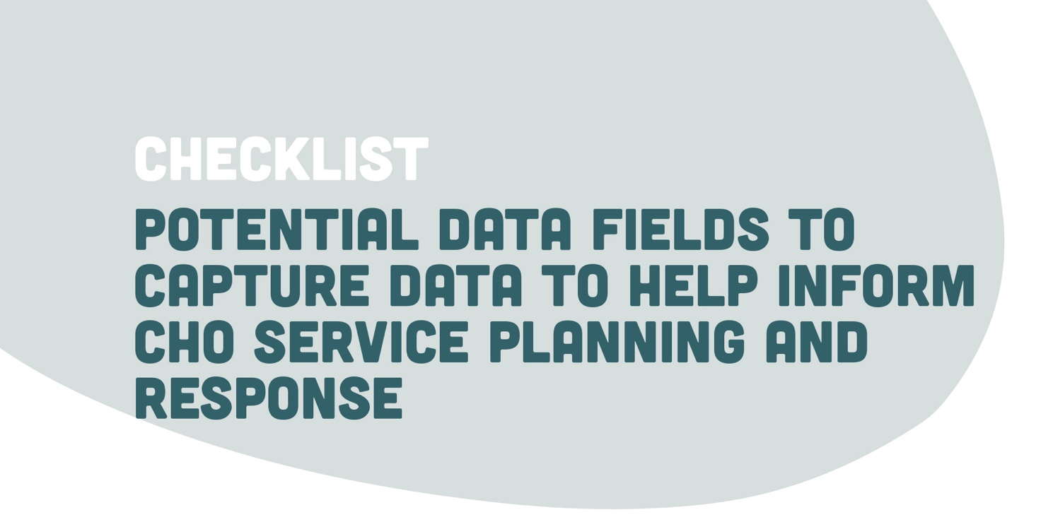

Consideration needs to be given to how this information is stored, in line with organisation privacy and confidentiality policies. Storing this information on an intranet site that is accessible to only a certain number of identified individuals is worth consideration.
* = information required
** = Potentially could be recorded via community housing organisation asset IT system i.e. via a service request
Tenant code*
Date*
Suburb victim resides in*
Suburb incident occurred in*
Nature of DFV incident (explanation of types of incident provided at end of template) | Verbal | Physical | Financial
 | Sexual | Emotional | Psychological
 | Harassment | Other
Referred for medical treatment (where necessary for physical injuries) | Yes | No | Unsure
Report made to police | Yes | No | Unsure
Referred to DFV service | Yes | No | Unsure
Did they engage with DFV support | Yes | No | Unsure
Safety Plan in place | Yes | No | Unsure
Current ADVO | Yes | No | Unsure
Are there children at risk* | Yes | No | Unsure
Mandatory report made* | Yes | No | Unsure
Children taken into care | Yes | No | Unsure
Suspected property damage** | Yes | No | Unsure
Safety modifications undertaken** | Yes | No | Unsure
If yes, list type of modification and cost, including who is responsible for such costs:
NCAT Action | Yes | No | Unsure
If yes, in relation to what breaches and what was the outcome of the NCAT hearing:
Has there been a history of DFV or other incidents that have required management or intervention?
Victim separated from perpetrator | Yes | No | Unsure
Eviction | Yes | No
Has the perpetrator left the property? | Yes | No | Unsure
Worker Name: |  | Worker email address:
Tenant Code* |  | Property Code*

The nature of the DFV incident categories are taken from FACS NSW and the Office for Women.
VERBAL ABUSE | PHYSICAL ABUSE
- Swearing and continual humiliation, in public or private  - Attacks on intelligence, sexuality, body image and capacity as a parent and spouse  - Ridiculing religious beliefs or ethnic background  - Screaming, shouting, name-calling, put-downs | - Direct assault on the body (choking, strangulation, shaking, eye injuries, biting, slapping, pushing, spitting, burning, punching, kicking, pulling hair)  - Use of weapons, including objects  - Hurting the children  - Locking the victim in or out of the house or rooms  - Forcing the victim to take drugs  - Not allowing medication, food or medical care  - Not allowing sleep
FINANCIAL ABUSE | SEXUAL ABUSE
- Forbidding access to bank accounts  - Providing only a small ‘allowance’  - Not allowing the victim to work or have a job  - Forcing the victim to sign documents or make false declarations  - Using all the wages earned by the victim for household expenses  - Controlling the victim’s pension  - Denying that the victim is entitled to joint property | - Any form of pressured or unwanted sex or sexual degradation causing pain during sex  - Assaulting genitals  - Forced sex without protection against pregnancy or sexually transmitted disease  - Making the victim perform sexual acts unwillingly (including taking or distributing explicit photos without their consent)  - Criticising or using sexually degrading insults
EMOTIONAL ABUSE | PSYCHOLOGICAL ABUSE
- Blaming the victim for all problems in the relationship  - Constantly comparing the victim with others to undermine their self-esteem and self-worth  - Sporadic sulking  - Withdrawing all interest and engagement (for example, weeks of silent treatment)  - Emotional blackmail and suicidal threats | - Creating fear, such as driving dangerously, possessing weapons, angry looks  - Destroying property or valued possessions  - Hurting or killing pets in front of family members  - Making threats regarding custody of any children  - Saying that the police and courts will not help, support or believe the victim  - Threatening to “out” the person
HARASSMENT | OTHER
- Following and watching  - Telephone and online harassment  - Tracking with Global Positioning Systems (GPS)  - Being intimidating  - Entering the home without permission | - Spiritual or religious abuse  - Image based abuse  - Reproductive abuse

https://www.facs.nsw.gov.au/domestic-violence/about/types-of-abuse-in-dv

