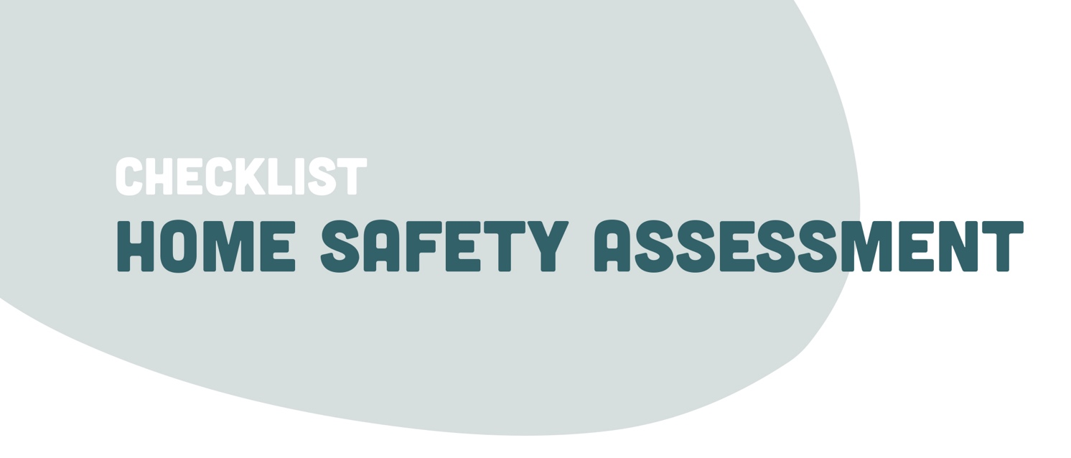

The home safety assessment can be undertaken by any community housing employee and given to the relevant housing/tenancy worker in your organisation.
OUTSIDE – FRONT AND BACK YARD | YES | NO
Is the street number clearly visible from the street?
Is the street number visible at night?
Can people see the home clearly from the street?
Could a person be seen hiding in the yard?
Can you stop people from getting under the home?
Is there sensor lighting installed?
Does the sensor lighting work?
Are entry and exit points adequately lit?
Are there light timers?
Does the letterbox have a lock?
Is the electricity meter enclosed in a box?
Is there an approved lock on the meter box?
Can the garage be locked?
Are bins, ladders etc. away from windows and gates?
Is there a fence or lockable gate stopping easy access to the rear yard?

DOORS | YES | NO
Are external doors solid?
Are the door frames solid and in good condition?
Do all doors have good quality locks?
Do door locks have a single bolt system?
Do door locks have a double bolt system?
Are the locks in good working order?
Does the front door have a peephole?
Is a security screen door installed?
Are sliding doors fitted with key locks?

WINDOWS (and other common area access points) | YES | NO
Are windows of solid construction?
Are window locks fitted?
Are unused windows permanently closed and secured?
Are windows able to be locked in a partially open position?
Can windows be opened for ventilation if needed?
Are manhole covers locked?
Are there louver windows?
Are skylights secured?

KEYS | YES | NO
Is the location of all keys (windows and doors) known?
Are keys out of view when the home is not occupied?
Are security/screen door keys removed from the lock?

MONITORING SYSTEMS | YES | NO
Is there a security camera installed?
Is the security camera in working condition?
Is the security camera tested regularly?

TELEPHONE | YES | NO
Can telephone lines be tampered with?
Are telephones pre-programmed with emergency contact numbers?
Has the phone number been changed?
Is the new phone number a silent number?

ANY ADDITIONAL OBSERVATIONS | YES | NO

