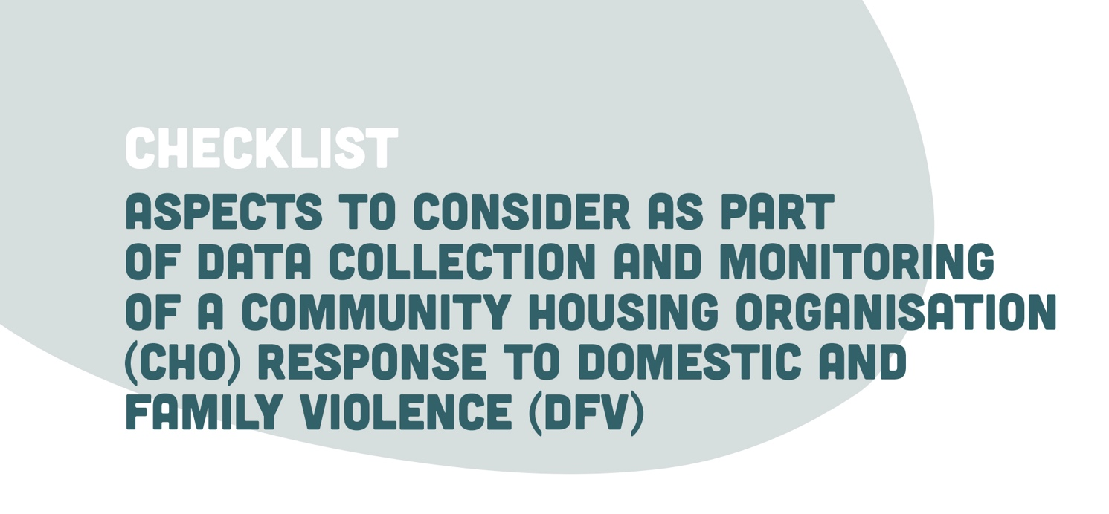

ISSUE | REFLECTION POINT | ACTION POINT
Identifying and recording incidents of DFV | - How do incidents of DFV get identified and recorded across the CHOs systems including:  - Nuisance and annoyance complaints  - Rental arrears  - Tenancy management  - Property damage | - Identify person to be responsible to review data collection processes across all of the CHOs systems  - Develop a plan to phase DFV data collection processes into the CHOs systems as systems are reviewed and updated  - Develop an implementation strategy to strengthen DFV data collection processes that includes educating staff on the importance of this data collection system
Defining a domestic and family violence incident | - Has the CHO established a policy with clear definitions of the range of behaviours present within DFV to strengthen staff understanding and awareness of DFV, such as adopting the policy in Module 2 of the toolkit? | - Ensure a policy is in place that clearly defines DFV  - All staff are trained to support implementation of the DFV policy.
Understanding response to home safety modifications | - Has the CHO utilised the Home Safety Assessment Checklist in Module 2 of the toolkit?  - Is the CHO able to quantify the cost of home safety modifications? | - Explore how data collected in the Home Safety Modification Checklist can be captured in the data collection system to inform ongoing monitoring and review of practice
Monitoring the cost and type of property damage as a result of DFV | - Does the CHO have a mechanism to capture, monitor and review the cost and types of property damage as a result of DFV? | - As part of data systems review, establish a mechanism to monitor and review cost and types of property damage
Building a sustainable tenancies approach from establishment of a tenancy to strengthen awareness and understanding of potential issues impacting new tenants | - How skilled and confident are CHO access and allocations staff in engaging with applicants to explore a possible history of DFV?  - Does the CHO utilise the tenant resource on DFV from Module 2 of the toolkit during lease sign ups to showcase understanding and commitment to a positive service response for victims of DFV? | - Explore customisation and utilisation of the tenant information resource on DFV from Module 2 of the toolkit to raise the profile of the CHO commitment to effective responses to DFV  - Identify key opportunities to explore the tenant information resource with all new tenants
Monitoring progress in delivering a good practice response to DFV across tenancies | - Does the CHO seek feedback safely from tenants about the response to safety and DFV?  - Does the CHO undertake follow up to monitor and support victim safety?  - Are regular reports compiled from data collected to monitor effective tenancy support and sustainment? | - Explore development of safe approaches to seeking feedback  - Safety for victims underpins all your data collection and tenant engagement  - A process is in place to monitor follow up post incident  - Monthly analysis of data and performance is undertaken to inform practice

